Chapter 2: Stack and Queues
1)What is Satck?
A Stack is a linear data structure that follows the LIFO (Last-In-First-Out) principle. It contains only one pointer top pointer pointing to the topmost element of the stack. Whenever an element is added in the stack, it is added on the top of the stack, and the element can be deleted only from the stack. In other words, a stack can be defined as a container in which insertion and deletion can be done from the one end known as the top of the stack.

key points related to stack
- It is called as stack because it behaves like a real-world stack, piles of books, etc.
- A Stack is an abstract data type with a pre-defined capacity, which means that it can store the elements of a limited size.
- It is a data structure that follows some order to insert and delete the elements, and that order can be LIFO or FILO.

Working of Stack
Stack works on the LIFO pattern. As we can observe in the below figure there are five memory blocks in the stack; therefore, the size of the stack is 5.
Suppose we want to store the elements in a stack and let's assume that stack is empty. We have taken the stack of size 5 as shown below in which we are pushing the elements one by one until the stack becomes full.
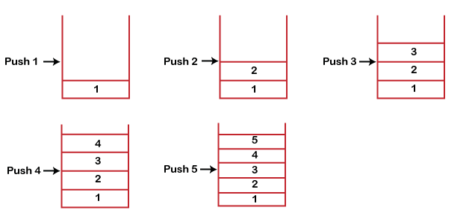
From the above figure stack is full as the size of the stack is 5. In the above cases, we can observe that it goes from the top to the bottom when we were entering the new element in the stack. The stack gets filled up from the bottom to the top.
When we perform the delete operation on the stack, there is only one way for entry and exit as the other end is closed. It follows the LIFO pattern, which means that the value entered first will be removed last. In the above case, the value 5 is entered first, so it will be removed only after the deletion of all the other elements.
Common operations implemented on the stack:
- push(): When we insert an element in a stack then the operation is known as a push. If the stack is full then the overflow condition occurs.
- pop(): When we delete an element from the stack, the operation is known as a pop. If the stack is empty means that no element exists in the stack, this state is known as an underflow state.
- isEmpty(): It determines whether the stack is empty or not.
- isFull(): It determines whether the stack is full or not.'
- peek(): It returns the element at the given position.
- count(): It returns the total number of elements available in a stack.
- change(): It changes the element at the given position.
- display(): It prints all the elements available in the stack.
Push Operation:
- Step 1 − Checks if the stack is full.
- Step 2 − If the stack is full, produces an error and exit.
- Step 3 − If the stack is not full, increments top to point next empty space.
- Step 4 − Adds data element to the stack location, where top is pointing.
- Step 5 − Returns success.
Algorithm for Push:
begin with push: stack, data
if stack is full
return null
endif
top ← top + 1
stack[top] ← data
End of push operation
Pop Operation:
- Accessing the content while removing it from the stack, is known as a Pop Operation.
- In an array implementation of pop() operation, the data element is not actually removed, instead top is decremented to a lower position in the stack to point to the next value.
- But in linked-list implementation, pop() actually removes data element and deallocates memory space.
- A Pop operation may involve the following steps −
- Step 1 − Checks if the stack is empty.
- Step 2 − If the stack is empty, produces an error and exit.
- Step 3 − If the stack is not empty, accesses the data element at which top is pointing.
- Step 4 − Decreases the value of top by 1.
- Step 5 − Returns success.
Algorithm
- begin pop: stack
- if stack is empty
- return null
- endif

- data ← stack[top]
- top ← top - 1
- return data
- end pop
Application of Stack:
- String reversal: Stack is also used for reversing a string. After pushing all the characters, we start taking out the character one by one until we reach the bottom of the stack.
- UNDO/REDO: It can also be used for performing UNDO/REDO operations. For example, we have an editor in which we write 'a', then 'b', and then 'c'; therefore, the text written in an editor is abc. So, there are three states, a, ab, and abc, which are stored in a stack. There would be two stacks in which one stack shows UNDO state, and the other shows REDO state.
If we want to perform UNDO operation, and want to achieve 'ab' state, then we implement pop operation.
- Recursion: The recursion means that the function is calling itself again. To maintain the previous states, the compiler creates a system stack in which all the previous records of the function are maintained.
- DFS(Depth First Search): This search is implemented on a Graph, and Graph uses the stack data structure.
- Backtracking: Suppose we have to create a path to solve a maze problem. If we are moving in a particular path, and we realize that we come on the wrong way. In order to come at the beginning of the path to create a new path, we have to use the stack data structure.
- Expression conversion: Stack can also be used for expression conversion. This is one of the most important applications of stack. The list of the expression conversion is given below:
- Infix to prefix
- Infix to postfix
- Prefix to infix
- Prefix to postfix
Postfix to infix
- Memory management: The stack manages the memory. The memory is assigned in the contiguous memory blocks. The memory is known as stack memory as all the variables are assigned in a function call stack memory. The memory size assigned to the program is known to the compiler. When the function is created, all its variables are assigned in the stack memory. When the function completed its execution, all the variables assigned in the stack are released.

Program Implementation of stack:
class Node {
constructor(value) {
if (value === null || value === undefined)
throw new Error("Initialise node with a 'valid' value");
this.value = value;
this.next = null;
}
}
class Stack {
constructor(value) {
const newNode = new Node(value);
this.top = newNode;
this.length = 1;
}
push(value) {
const newNode = new Node(value);
if (!this.length) {
this.top = newNode;
} else {
newNode.next = this.top;
this.top = newNode;
}
this.length++;
return this;
}
pop() {
let temp = this.top;
if (!this.height) return undefined;
else {
temp = this.top;
this.top = temp.next;
temp.next = null;
}
this.length--;
return temp;
}
isEmpty() {
return this.top.length == 0;
}
peek() {
return this.top;
}
}
const newstack = new Stack(3);
newstack.push(5);
console.log(newstack);

Application of Stack in real life:
- CD/DVD stand.
- Stack of books in a book shop.
- Undo and Redo mechanism in text editors.
- The history of a web browser is stored in the form of a stack.
- Call logs, E-mails, and Google photos in any gallery are also stored in form of a stack.
- YouTube downloads and Notifications are also shown in LIFO format(the latest appears first ).
Advantages of Stack:
- Stack helps in managing data that follows the LIFO technique.
- Stacks are be used for systematic Memory Management.
- It is used in many virtual machines like JVM.
- When a function is called, the local variables and other function parameters are stored in the stack and automatically destroyed once returned from the function. Hence, efficient function management.
- Stacks are more secure and reliable as they do not get corrupted easily.
- Stack allows control over memory allocation and deallocation.
- Stack cleans up the objects automatically.
Disadvantages of Stack:
- Stack memory is of limited size.
- The total of size of the stack must be defined before.
- If too many objects are created then it can lead to stack overflow.
- Random accessing is not possible in stack.
- If the stack falls outside the memory it can lead to abnormal termination.

2)What is Queue?
1. A queue can be defined as an ordered list which enables insert operations to be performed at one end called REAR and delete operations to be performed at another end called FRONT.
2. Queue is referred to be as First In First Out list.
3. For example, people waiting in line for a rail ticket form a queue.
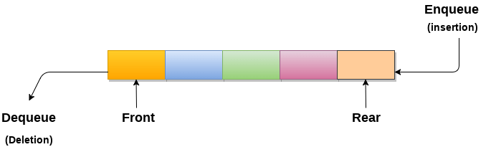

Basic Operations
- Queue operations may involve initializing or defining the queue, utilizing it, and then completely erasing it from the memory. Here we shall try to understand the basic operations associated with queues −
- enqueue() − add (store) an item to the queue.
- dequeue() − remove (access) an item from the queue.
- peek() − Gets the element at the front of the queue without removing it.
- isfull() − Checks if the queue is full.
- isempty() − Checks if the queue is empty.
Enqueue Operation:
- Queues maintain two data pointers, front and rear. Therefore, its operations are comparatively difficult to implement than that of stacks.
- The following steps should be taken to enqueue (insert) data into a queue −
- Step 1 − Check if the queue is full.
- Step 2 − If the queue is full, produce overflow error and exit.
- Step 3 − If the queue is not full, increment rear pointer to point the next empty space.
- Step 4 − Add data element to the queue location, where the rear is pointing.
- Step 5 − return success.
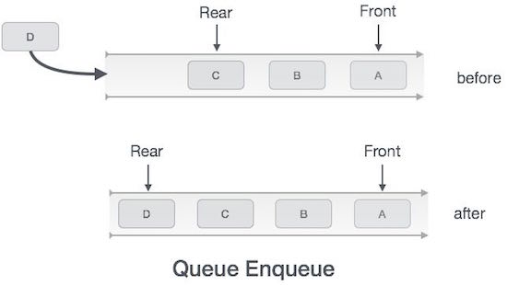
Algorithm for enqueue operation:
procedure enqueue(data)

if queue is full
return overflow
endif
rear ← rear + 1
queue[rear] ← data
return true
end procedure

De-queue Operation:
- Accessing data from the queue is a process of two tasks − access the data where front is pointing and remove the data after access. The following steps are taken to perform dequeue operation −
- Step 1 − Check if the queue is empty.
- Step 2 − If the queue is empty, produce underflow error and exit.
- Step 3 − If the queue is not empty, access the data where front is pointing.
- Step 4 − Increment front pointer to point to the next available data element.
- Step 5 − Return success.
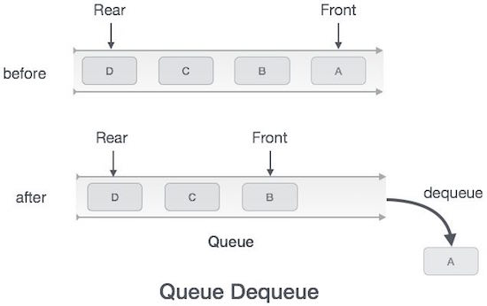
Algorithm for de-queue operation
procedure dequeue
if queue is empty
return underflow
end if
data = queue[front]
front ← front + 1
return true
end procedure
isfull()
- As we are using single dimension array to implement queue, we just check for the rear pointer to reach at MAXSIZE to determine that the queue is full.
- case we maintain the queue in a circular linked-list, the algorithm will differ.
Algorithm of isfull() function –
begin procedure isfull
if rear equals to MAXSIZE
return true
else
return false
endif
end procedure

isempty():
Algorithm
begin procedure isempty
if front is less than MIN OR front is greater than rear
return true
else
return false
endif
end procedure

peek():
This function helps to see the data at the front of the queue. The algorithm of peek() function is as follows −
Algorithm
begin procedure peek
return queue[front]
end procedure

Program Implementation of Queue and its various operations:

class Node {
constructor(value) {
if (value == null || value == undefined)
throw new Error("Initialise node with a 'valid' value");
this.value = value;
this.next = null;
}
}

// FIFO
class Queue {
constructor(value) {
const newNode = new Node(value);
this.front = newNode;
this.rear = this.front;
this.length = 1;
}
enqueue(value) {
const newNode = new Node(value);
if (!this.length) {
this.front = newNode;
this.rear = this.front; ///(rear)20<---next|10(front)
} else {
this.rear.next = newNode;
this.rear = newNode;
}
this.length++;
return this;
}
}
const myqueue = new Queue(10);
console.log(myqueue);
myqueue.enqueue(20);
console.log(myqueue);
Applications of Queue:
- Multi programming: Multi programming means when multiple programs are running in the main memory. It is essential to organize these multiple programs and these multiple programs are organized as queues.
- Network: In a network, a queue is used in devices such as a router or a switch. another application of a queue is a mail queue which is a directory that stores data and controls files for mail messages.
- Job Scheduling: The computer has a task to execute a particular number of jobs that are scheduled to be executed one after another. These jobs are assigned to the processor one by one which is organized using a queue.
- Shared resources: Queues are used as waiting lists for a single shared resource.
Advantages of Queue:
- A large amount of data can be managed efficiently with ease.
- Operations such as insertion and deletion can be performed with ease as it follows the first in first out rule.
- Queues are useful when a particular service is used by multiple consumers.
- Queues are fast in speed for data inter-process communication.
- Queues can be used in the implementation of other data structures.
Disadvantages of Queue:
- The operations such as insertion and deletion of elements from the middle are time consuming.
- Limited Space.
- In a classical queue, a new element can only be inserted when the existing elements are deleted from the queue.
- Searching an element takes O(N) time.
- Maximum size of a queue must be defined prior.
3)What is Circular Queue?
There was one limitation in the array implementation of Queue. If the rear reaches to the end position of the Queue then there might be possibility that some vacant spaces are left in the beginning which cannot be utilized. So, to overcome such limitations, the concept of the circular queue was introduced.
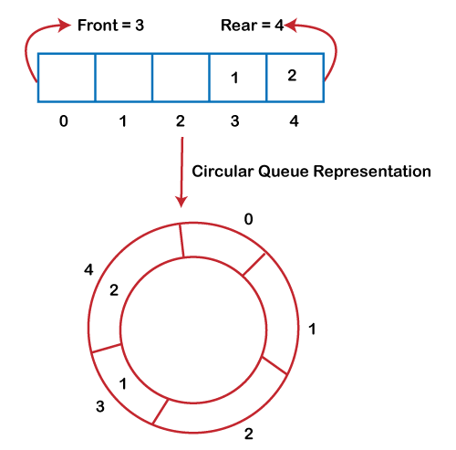
As we can see in the above image, the rear is at the last position of the Queue and front is pointing somewhere rather than the 0th position. In the above array, there are only two elements and other three positions are empty. The rear is at the last position of the Queue; if we try to insert the element then it will show that there are no empty spaces in the Queue. There is one solution to avoid such wastage of memory space by shifting both the elements at the left and adjust the front and rear end accordingly. It is not a practically good approach because shifting all the elements will consume lots of time. The efficient approach to avoid the wastage of the memory is to use the circular queue data structure.
A circular queue is similar to a linear queue as it is also based on the FIFO (First In First Out) principle except that the last position is connected to the first position in a circular queue that forms a circle. It is also known as a Ring Buffer.

Operations on Circular Queue:
The following are the operations that can be performed on a circular queue:
- Front: It is used to get the front element from the Queue.
- Rear: It is used to get the rear element from the Queue.
- enQueue(value): This function is used to insert the new value in the Queue. The new element is always inserted from the rear end.
- deQueue(): This function deletes an element from the Queue. The deletion in a Queue always takes place from the front end.

Enqueue operation
The steps of enqueue operation are given below:
- First, we will check whether the Queue is full or not.
- Initially the front and rear are set to -1. When we insert the first element in a Queue, front and rear both are set to 0.
- When we insert a new element, the rear gets incremented, i.e., rear=rear+1.

Scenarios for inserting an element
There are two scenarios in which queue is not full:
- If rear != max - 1, then rear will be incremented to mod(maxsize) and the new value will be inserted at the rear end of the queue.
- If front != 0 and rear = max - 1, it means that queue is not full, then set the value of rear to 0 and insert the new element there.
There are two cases in which the element cannot be inserted:
- When front ==0 && rear = max-1, which means that front is at the first position of the Queue and rear is at the last position of the Queue.
- front== rear + 1;
Algorithm to insert an element in a circular queue
- Front: Get the front item from queue.
- Rear: Get the last item from queue.
- enQueue(value) This function is used to insert an element into the circular queue. In a circular queue, the new element is always inserted at Rear position.
  - Check whether queue is Full – Check ((rear == SIZE-1 && front == 0) || (rear == front-1)).
  - If it is full then display Queue is full. If queue is not full then, check if (rear == SIZE – 1 && front != 0) if it is true then set rear=0 and insert element.
- deQueue() This function is used to delete an element from the circular queue. In a circular queue, the element is always deleted from front position.
  - Check whether queue is Empty means check (front==-1).
  - If it is empty then display Queue is empty. If queue is not empty then step 3
  - Check if (front==rear) if it is true then set front=rear= -1 else check if (front==size-1), if it is true then set front=0 and return the element.

Steps to implement Circular Queue using Array:
- Initialize an array queue of size n, where n is the maximum number of elements that the queue can hold.
- Initialize two variables front and rear to -1.
- To enqueue an element x onto the queue, do the following:
  - Increment rear by 1.
  - If rear is equal to n, set rear to 0.
  - If front is -1, set front to 0.
  - Set queue[rear] to x.
- To dequeue an element from the queue, do the following:
  - Check if the queue is empty by checking if front is -1. If it is, return an error message indicating that the queue is empty.
  - Set x to queue[front].
  - If front is equal to rear, set front and rear to -1.
  - Otherwise, increment front by 1 and if front is equal to n, set front to 0.
  - Return x.
Program Implementation of Circular Queue:
class Circularqueue {
constructor(maxcapacity) {
this.data = Array(maxcapacity); //array creation with maxcapacity
this.capacity = maxcapacity; //capacity property is set to maxcapacity
this.currentlength = 0; // crrent length is zero
this.front = -1; //crrently not poinitng to any queue element
this.rear = -1;
}
isFull() {
return this.currentLength === this.capacity;
}
isEmpty() {
return this.currentLength === 0;
}
enqueue(data) {
if (!this.isFull()) {
this.rear = (this.rear + 1) % this.capacity; //increment rear pointer by 1
this.data[this.rear] = data; //add data and rear pointer index
this.currentlength++;
if (this.front === -1) {
this.front = this.rear;
}
}

return data;
}
dequeue() {
if (this.isEmpty()) {
return null;
}
let temp = this.data[this.front]; // store the front element that need to deleted in temp
this.data[this.front] = null; //index of that front element will be null
this.front = (this.front + 1) % this.capacity; //increment front by 1 to delete another element
this.currentlength - 1;
if (this.isEmpty()) {
this.front = -1;
this.rear = -1;
}
return temp;
}
peek() {
if (!this.isEmpty()) {
return this.items[this.front];
}
return null;
}
}

const circular = new Circularqueue(7);
circular.enqueue(2);
circular.enqueue(2);
circular.enqueue(2);
circular.enqueue(2);
circular.enqueue(2);
circular.enqueue(2);
circular.enqueue(2);
console.log(circular);
console.log(circular.dequeue());
console.log(circular);

Applications of Circular Queue:
- In a page replacement algorithm, a circular list of pages is maintained and when a page needs to be replaced, the page in the front of the queue will be chosen.
- Computer systems supply a holding area for maintaining communication between two processes or two programs. This memory area is also known as a ring buffer.
- CPU Scheduling: In the Round-Robin scheduling algorithm, a circular queue is utilized to maintain processes that are in a ready state.
Advantages of Circular Queue:
- It provides a quick way to store FIFO data with a maximum size.
- Efficient utilization of the memory.
- Doesn’t use dynamic memory.
- Simple implementation.
- All operations occur in O(1) constant time.
Disadvantages of Circular Queue:
- In a circular queue, the number of elements you can store is only as much as the queue length, you have to know the maximum size beforehand.
4)What is Priority Queue?
Priority Queue is an abstract data type that is similar to a queue, and every element has some priority value associated with it. The priority of the elements in a priority queue determines the order in which elements are served (i.e., the order in which they are removed). If in any case the elements have same priority, they are served as per their ordering in the queue.

Properties of Priority Queue
So, a priority Queue is an extension of the queue with the following properties.
- Every item has a priority associated with it.
- An element with high priority is dequeued before an element with low priority.
- If two elements have the same priority, they are served according to their order in the queue.

How is Priority assigned to the elements in a Priority Queue?
In a priority queue, generally, the value of an element is considered for assigning the priority.
For example, the element with the highest value is assigned the highest priority and the element with the lowest value is assigned the lowest priority. The reverse case can also be used i.e., the element with the lowest value can be assigned the highest priority. Also, the priority can be assigned according to our needs.

Operations of a Priority Queue:
A typical priority queue supports the following operations:

1) Insertion in a Priority Queue
When a new element is inserted in a priority queue, it moves to the empty slot from top to bottom and left to right. However, if the element is not in the correct place then it will be compared with the parent node. If the element is not in the correct order, the elements are swapped. The swapping process continues until all the elements are placed in the correct position.

2) Deletion in a Priority Queue
As you know that in a max heap, the maximum element is the root node. And it will remove the element which has maximum priority first. Thus, you remove the root node from the queue. This removal creates an empty slot, which will be further filled with new insertion. Then, it compares the newly inserted element with all the elements inside the queue to maintain the heap invariant.

Types of Priority Queue:

1) Ascending Order Priority Queue
As the name suggests, in ascending order priority queue, the element with a lower priority value is given a higher priority in the priority list. For example, if we have the following elements in a priority queue arranged in ascending order like 4,6,8,9,10. Here, 4 is the smallest number, therefore, it will get the highest priority in a priority queue and so when we dequeue from this type of priority queue, 4 will remove from the queue and dequeue returns 4.

2) Descending order Priority Queue
The root node is the maximum element in a max heap, as you may know. It will also remove the element with the highest priority first. As a result, the root node is removed from the queue. This deletion leaves an empty space, which will be filled with fresh insertions in the future. The heap invariant is then maintained by comparing the newly inserted element to all other entries in the queue.

Algorithm:
Implement Priority Queue using Linked Lists.
push(): This function is used to insert a new data into the queue.
pop(): This function removes the element with the highest priority from the queue.
peek() / top(): This function is used to get the highest priority element in the queue without removing it from the queue.
PUSH(HEAD, DATA, PRIORITY):
Step 1: Create new node with DATA and PRIORITY
Step 2: Check if HEAD has lower priority. If true follow Steps 3-4 and end. Else goto Step 5.
Step 3: NEW -> NEXT = HEAD
Step 4: HEAD = NEW
Step 5: Set TEMP to head of the list
Step 6: While TEMP -> NEXT != NULL and TEMP -> NEXT -> PRIORITY > PRIORITY
Step 7: TEMP = TEMP -> NEXT
[END OF LOOP]
Step 8: NEW -> NEXT = TEMP -> NEXT
Step 9: TEMP -> NEXT = NEW
Step 10: End
POP(HEAD):
Step 1: Set the head of the list to the next node in the list. HEAD = HEAD -> NEXT.
Step 2: Free the node at the head of the list
Step 3: End
PEEK(HEAD):
Step 1: Return HEAD -> DATA
Step 2: End
Program Implementation of Priority Queue:
class Node {
// Lower values indicate
// higher priority
constructor() {
this.data = 0;
this.priority = 0;
this.next = null;
}
}

// Function to Create A New Node
function newNode(d, p) {
var temp = new Node();
temp.data = d;
temp.priority = p;
temp.next = null;

return temp;
}

// Function to push according to priority
function push(head, d, p) {
var start = head;

// Create new Node
var temp = newNode(d, p);

// Special Case: The head of list
// has lesser priority than new node.
// So insert new node before head node
// and change head node.
if (head.priority > p) {
// Insert New Node before head
temp.next = head;
head = temp;
} else {
// Traverse the list and find a
// position to insert new node
while (start.next != null && start.next.priority < p) {
start = start.next;
}
// Either at the ends of the list
// or at required position
}
return head;
}
// Return the value at head
// Removes the element with the
// highest priority from the list
function pop(head) {
var temp = head;
head = head.next;
return head;
}
var pq = newNode(4, 1);
pq = push(pq, 5, 2);
pq = push(pq, 6, 3);
//pq = push(pq, 7, 0);
console.log(JSON.stringify(pq));
pq = pop(pq);
console.log(pq);

Applications of Priority Queue:
- CPU Scheduling
- Graph algorithms like Dijkstra’s shortest path algorithm, Prim’s Minimum Spanning Tree, etc.
- Stack Implementation
- Data compression in Huffman code
- Event-driven simulation such as customers waiting in a queue.
- Finding Kth largest/smallest element.
Advantage:
Priority queue is that nodes can be weighted, allowing those with greater precedence to be moved towards the head of the queue, in front of those with lesser priority, rather than always being added to the tail of the queue as would happen in a normal queue.
Disadvantage:
Insertions are no longer performed in constant time as new nodes must use insertion sort to find their place in the queue (behind nodes with greater or equal priority). However, if the variable weights are finite, maintaining pointers for each weight in a static array will provide constant time insertions.

